EVeHelp Official Change Log

(Debugging and Instructions Log)

Spresense Write Up: <https://docs.google.com/document/d/1cHBwsehvIXRTZQCubzxj_toqcKmab2Whq9DGKfKOazg/edit>

Initial Design Choices:

**Plan:**

**Anthony –**

* **Store audio in SD (“do you need help?)”**
  + **In SD reader case**
* **Make speaker from toy and test**
* **Do voice recognition thing with microphone**
* **Start CAD modeling**

**Edgar –**

* **GNSS testing**
* **LTE testing**
  + **Sim card in the Future Voter desk drawer**
* **Start CAD modeling**

**Wiring Diagrams for Reference:**

**These images contain pins we used for the gyroscope and so on…**

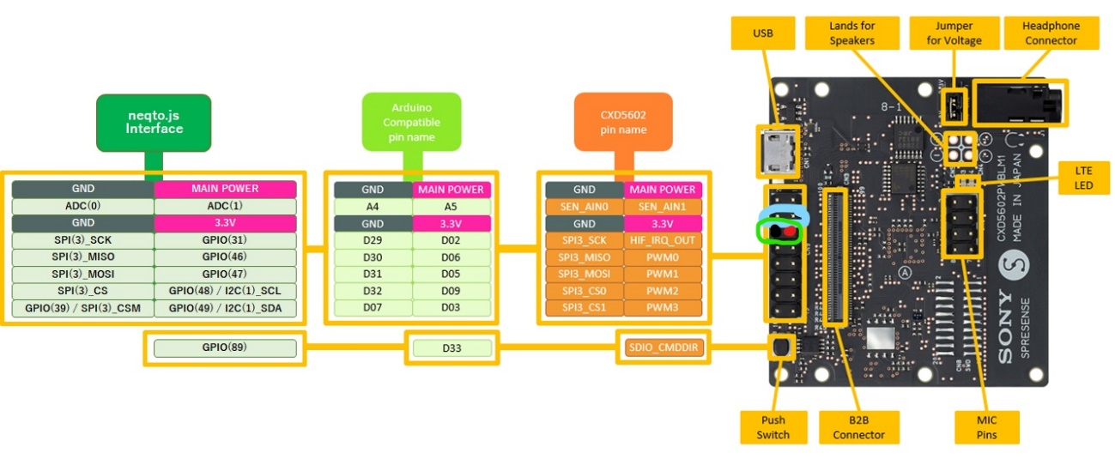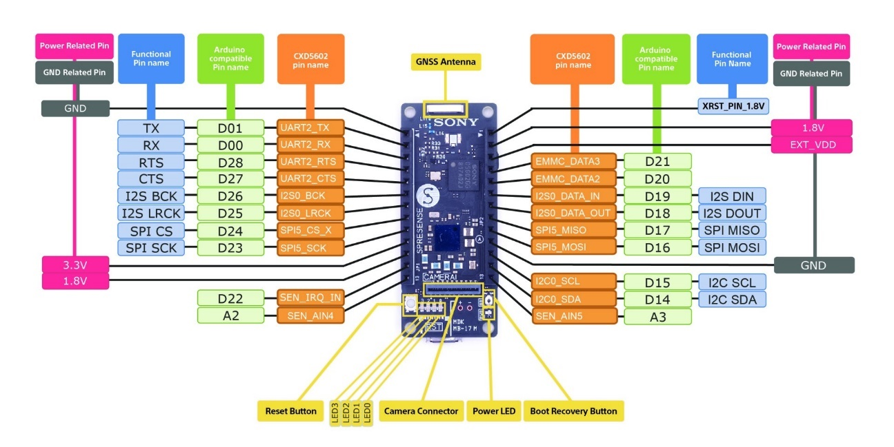

ISSUES WE ENCOUNTERED WITH REGARDS TO THE CONSTRUCTION OF THE DEVICE:

Error finding and collecting data 🡪 MPU 6050 with Spresense and Arduino:

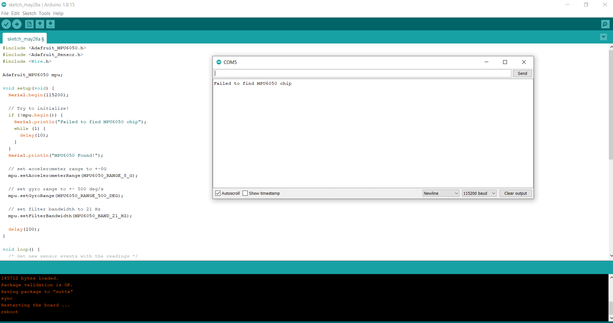

Attempt Solution 1: We tried to switch SCL and SDA pins on the MPU 6050. Did not work for detection. May have made it worse.

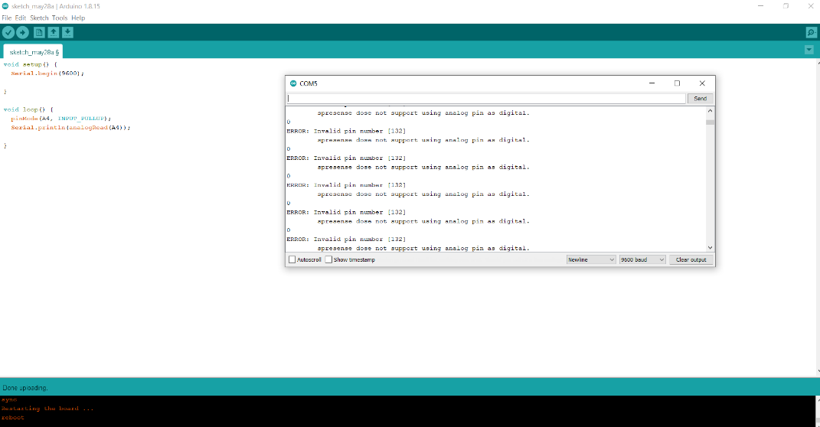

Attempt Solution 2: Turn on resistor within the Arduino that sends data to A4 pin and it said that it wanted us to use digital pins. Failed to accept pin input MPU6050.

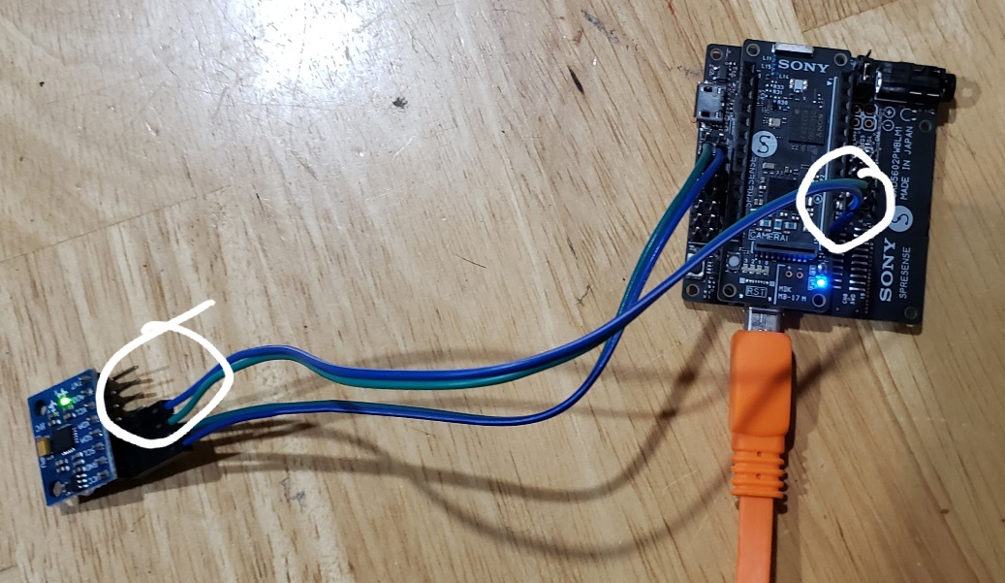Attempt Solution 3: The Main Board (Spresense) contains i2c SCL and SDA Pins for Arduino hardware such as the MPU 6050. We swapped our A4 and A5 Pins with the D15 (SCL) and D14 (SDA) pins and we were able to get raw rotation data.

Error doing something… ::::